

Queen Mary University of London Engineering School, NPU

Catapult: Application of Energy Storage and Reflection of Dynamics Theorems
(Team number: M18)

2023-2024

Revision 21 (issue for use)

Contents
Document Details 3
Key Referenced Documents 3
Team Details 3
Disclaimer 3
Pre-submission Check List 3
I. Introduction 4
1.1 Literature Review 4
1.2 Objectives 4
II Materials, Measurements and Methods 5
2.1 Mechanical Testing 5
2.2 Catapult Configuration and Testing 6
III Results 7
3.1 Mechanical Testing 7
3.2 Catapult Configuration and Testing 7
3.3 Actual Performance in the Challenge 8
IV Discussion 10
V Conclusions and recommendations 11
5.1 Conclusions 11
5.2 Recommendations 11
VI Reflection and AI Evaluation (maximum of 0.5 page or 100 words) 11
6.1 Team Reflection 11
6.2 AI Evaluation 11
VIII References 12

Document Details
- Document Number = QXU4015DOC24.R1
- Document File Name = QXU4015 – Catapult: Application of Energy Storage and Reflection of Dynamics Theorems – 18 (R1)
- Document Purpose = To provide reports on laboratory experiments related to QXU4015
- Document Version = Revision 21 (Issued for use)
- Document Issue Date = 4th April 2024
- Document Owner = Team M18

Key Referenced Documents
- QXU4015 Laboratory Experiment – Marking Rubric (R1) (available from week 8 on QM+)
- QXU4015 Guide to Writing Engineering Reports (R1 (available from week 8 on QM+)
- QXU4015 Laboratory Experiment – Overview Presentation (available from week 8 on QM+)
- QXU4014 Laboratory Experiment – Report Template (R1) (available from week 8 on QM+)

Team Details
Name | QMUL ID Number | Signature | Contribution Level for report
Xuanming Che | 2023304252 |  | Full
Haoyu Wu | 2023304250 |  | Full
Ruihan Zhang | 2023304242 |  | Full
Wenqing Cao | 2023304255 |  | Partial
yongqi Xu | 2023304251 |  | Partial
Tianshi Gao | 2023304255 |  | Full

Disclaimer
This report represents the work of 18 and is submitted in partial fulfilment of credit in QXU4015. The information presented herein is based on an undergraduate laboratory experiment and associated analysis. All work was conducted by the team and is intended solely for academic evaluation and educational purposes. All sources used in this report have been appropriately cited. The student and the university bear no responsibility for any consequences arising from the use of the information provided in this report. Reproduction or distribution of this report, in whole or in part, without authorisation of the module organiser.

Pre-submission Check List
- This document provides tips in the comments, ensure you have comments turned on so you can see them. Delete the comments before submission.
- This document contains advice in red text. Make sure you delete ALL the red text before submission and change the font back to black as needed.
- This document contains headers and footers, the headers need to be updated before submission.
- Check the marking rubric carefully as it contains useful information on how to complete this document.
- Ensure that ALL members of your team have reviewed and approved the document before submission.
Catapult: Application of Energy Storage and
Reflection of Dynamics Theorems

I. Introduction
Catapult is a kind of mechanical device which can store energy by installing elastic materials. As early as 10,000 BC, there were already prototypes of catapults in the world and they played significant roles in shaping history[1], [2]. Today, the principles of energy storage and release in catapults are widely used in many fields, from steam catapults to the electromagnetic ejection of aircraft carriers[3]. Therefore, a study of the principle and effect of catapults through this experiment is needed.

1.1 Literature Review
The XPULT, a catapult designed for experimentation (Figure 1), was developed by University of Pennsylvania professors and serves as the core of the experimental process [4]. Key theoretical principles include Young’s modulus, which describes the stress-to-strain ratio of a material during elastic deformation [5], and the fatigue testing theorem, which evaluates fatigue data under various loads or stretches [6]. The lever equilibrium condition ensures that the moments acting on the lever are balanced [7]. Additionally, the creep test assesses changes in material elasticity over time due to temperature and time under constant stress [8]. In tensile testing, the variable is the weight applied to the material, while in fatigue testing, it is the extent of stretching. The variable in the ejection test is the structure of the catapult. These variables are carefully controlled and tailored to the chosen material for the catapulting challenge.

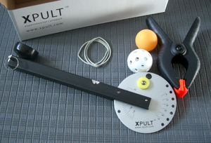
Figure 1. The XPULT catapult [4].

1.2 Objectives
The goal of the experiment is to test, selection and application of an energy storage material, evaluate a variety of materials’ properties according to which a catapult is designed and constructed that can get higher scores or closer to the prediction in the following challenge.
Specific instructions are as follows. The challenge involves taking 10 shots and holding the ball in place for five minutes before releasing it without making any adjustments. As the picture shows, the target is divided into 12 parts (Figure 2), the ball made of special material was catapulted into the target, generating different scores due to the falling location, the more centre the ball is located, the higher the mark will be given.
In the challenge prediction part, the mean value of points prediction is 2.2, since there might be few balls pop out of the target area. After repeating different kinds of distributions of values, the standard deviation prediction of all the statistics is 0.6481. For scoring the single ball after 5 minutes of holding, the score prediction is 8., due to the little fatigue of elastic materials, the force of catapulting after holding and the possibility for the ball to reflect will be decreased.
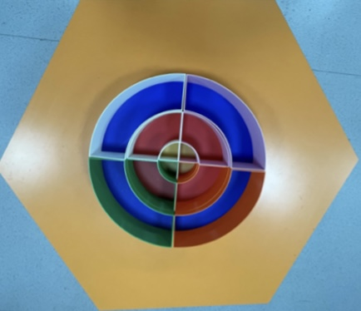
Figure 2. Target

II Materials, Measurements and Methods
In this experiment, tensile testing, fatigue testing, and catapult configuration and testing were performed. The experimental apparatus comprised a catapult, three samples(Figure 3), weights, a testing frame, and other requisite equipment. The experiment is conducted in room temperature (26°C).
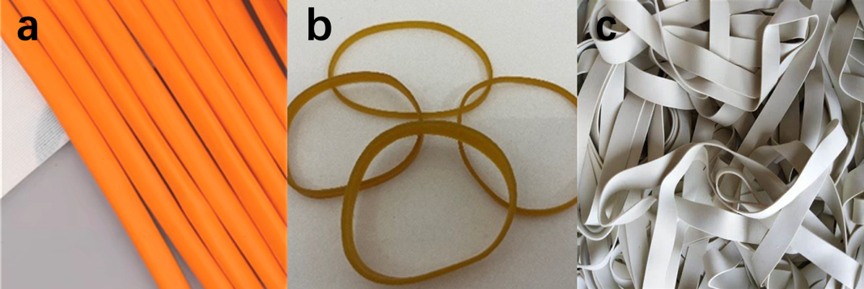
Figure 3. (a)Balloon sample. (b)Short rubber band sample. (c)Long rubber band sample.

2.1 Mechanical Testing

Type1: Tensile testing
The materials used in the tensile testing are assorted weights, assorted clips, catch, testing frames, digital vernier callipers with 20-micron resolution with 2 mm tolerance, 1-millimetre division value scale and three diverse kinds of rubbers signed samples a-c (Figure 3). The testing method is as follows:
(1) Draw two lines on three different rubber samples.
(2) Hang one end of each sample with a clip and attach the other end to a testing frame using a latch.
(3) Measure the distance between the two lines on each sample, then hang weights from the clip.
(4) Measure the elongation of the rubber samples using a scale. (Elongation = tensile length - original length)
(5) Record the weights and corresponding elongations in tables for data analysis.
Type2: Fatigue testing
The materials used in the fatigue testing are 0.1-newton division value spring dynamometer, 1-millimetre division value scale, S-hooks, testing frame, and digital vernier callipers. The testing steps are below:
(1) Hang the upper end of the test material using an S-hook and secure it to the testing frame.
(2) Secure the lower end of the test material with a clip and attach a spring dynamometer.
(3) Apply a consistent force to elongate the material to a fixed length using the spring dynamometer. Record the position of the lower end and the force displayed on the dynamometer.
(4) Repeat the process of applying force to elongate the material to the same position, recording the force every 100 or 150 times. Stop when the force noticeably decreases.
(5) Draw graphs to illustrate the relationship between the pulling times and the corresponding force.
To prevent weight, fall and smash injury, the original length between two lines of tensile testing should be appropriate. Pulled the materials from the starting point to the bottom point for a circle. Also be careful with the clip falling off the end of the material, simultaneously remember to avoid too strong shaking when pulling.

2.2 Catapult Configuration and Testing
In this experiment, design and iterative methods were employed to configure the catapult. The test involved placing the catapult on a plane, launching a ball, and recording its landing position on the same horizontal plane through multiple repetitions.
The first version of the catapult featured a complex structure comprising a red base, blue levers with a rubber band, and five plastic rods (Figure 4). Utilizing plastics a and c ensured consistent launch and pullback angles for each launch. However, experimental analysis revealed a significant rebound upon impact with the ground, necessitating further iterations.
The second version of the catapult featured modifications, including replacing the original material with a less elastic white rubber and using a longer white lever (Figure 5). These changes resulted in a reduction of the initial velocity of the projectile.

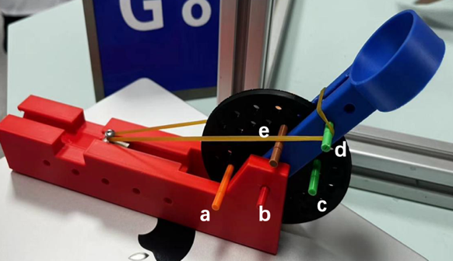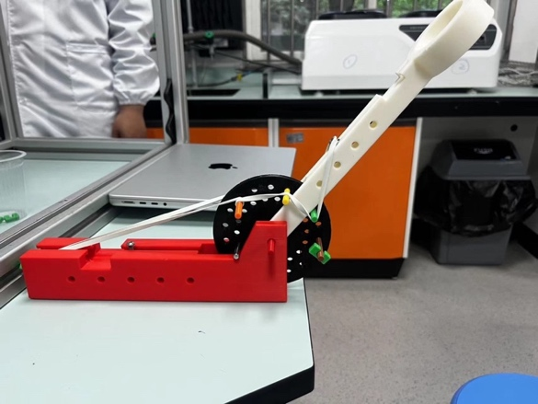
Figure 4. The first version of the catapult F

igure 5. The second version of the catapult

Despite improvements to the catapult's structure, the ball's elasticity remained high. Consequently, a layer of paper towel was wrapped around the surface of the ball to serve as a cushion upon landing, thereby reducing the rebound height. This adjustment led to the desired outcome of minimizing rebound height and improving overall performance. Due to the speed of the ball is relatively fast, there will be a relatively large error in the measurement.

III Results
Followed by the complete experiment process, the brief result analysis of the two parts is given.

3.1 Mechanical Testing
In tensile testing, within a certain elastic limit, the elongations of the materials showed a nearly linear relationship with the applied tensile force. The r square values in the fit curve are all larger than 0.97. Sample 3 has the highest degree (0.99146) of fit and the prediction is the most accurate (Figure 6a). Statistical analysis revealed that sample 3 exhibited the least sensitivity to weights, making it capable of storing more energy in the same elongation compared to the other materials, thus leading to its selection.
In fatigue testing, the performance of the three elastic materials varied. After 1200 stretching cycles, all materials maintained their original elasticity within a decrease of 0.5-1.0N. Additionally, the forces applied during the initial 1-350 cycles generally remained consistent. Notably, a significant portion of elasticity changes occurred between 650-1000 cycles, with no apparent change observed between 1000-1200 cycles(Figure 6b,c).

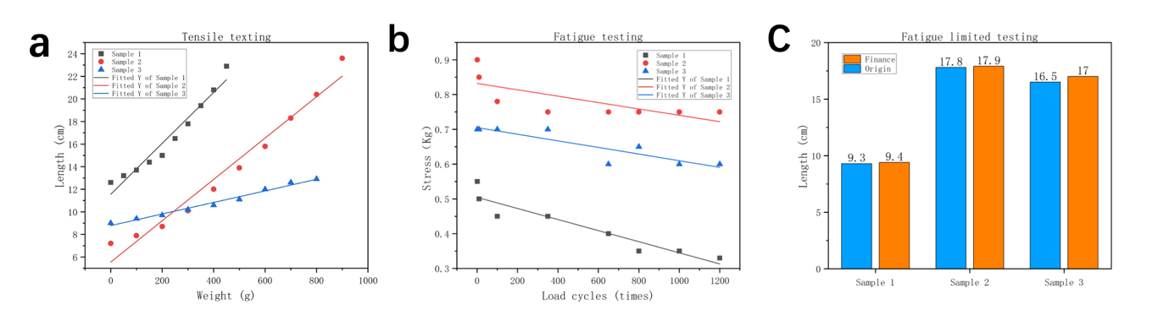
Figure 6. (a)Tensile testing. (b)Fatigue testing. (c)Fatigue limited testing after 1200 stretching cycles.

3.2 Catapult Configuration and Testing
Each version of the catapult and ball system underwent rigorous empirical testing, including scrutiny of landing point consistency to assess apparatus stability and measurement of post-rebound ball height to gauge target area hit probability.
Initial testing of the first version revealed a consistent rebound height of 15 cm, with landing points predominantly within a 3 cm radius circle. After one design iteration, the rebound height decreased to 12 cm, accompanied by increased landing point dispersion, primarily within a 5 cm radius circle. Subsequent refinement, involving ball wrapping, further reduced the rebound height to 5 cm, leading to the final version.

Finally, experimental simulations of real challenges were conducted, featuring specific distances and target zones (Figure 7). A total of 20 experiments were performed, with 15 landing in the "Mid – Red – 3 points" zone, 2 in the "Inner - Gold – 4 points" zone, 2 in the "Outer – Blue 2 points" zone, and 1 in the "Hit the surrounds – 1 point" zone.
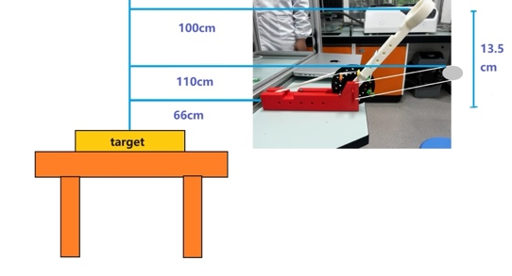

Figure 7. Simulation experiment.

3.3 Actual Performance in the Challenge

Table 1: The Challenge Part 1
Ball Number | Score | Quadrant | Observations
1 | Hit the surrounds – 1 point | Q3 - Orange | The ball hits the edge of inner-region, and bounced to the surrounds.
2 | Mid – Red – 3 points | Q4 - Pink | No rebound.
3 | Mid – Red – 3 points | Q4 - Pink | No rebound.
4 | Mid – Red – 3 points | Q1 - White | No rebound.
5 | Mid – Red – 3 points | Q4 - Pink | No rebound.
6 | Inner - Gold – 4 points | Q4 - Pink | No rebound.
7 | Inner - Gold – 4 points | Q4 - Pink | No rebound.
8 | Outer – Blue 2 points | Q3 - Orange | No rebound.
9 | Outer – Blue 2 points | Q2 - Green | The ball hits the edge of middle-region, and bounced to the outer region.
10 | Mid – Red – 3 points | Q2 - Green | No rebound.

Table 2: The Challenge Part 2
Ball Number | Score | Quadrant | Observations
1 | Red = 3 Points | Q3 - Orange | No rebound.

Teams Total Points = 70

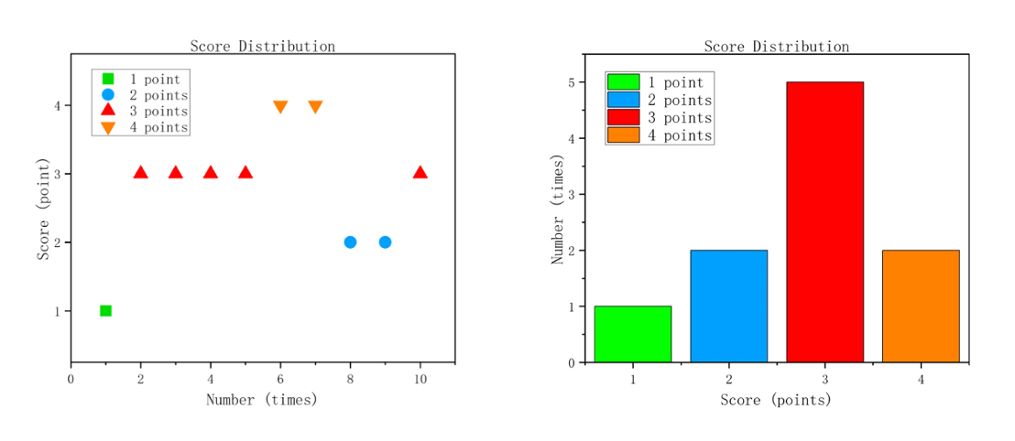
Figure 8. The score distribution of 10 throws.

IV Discussion
In Challenge 1, prediction 22 scored 28, which is high; In Challenge 2, both prediction and score are 8, and the prediction is accurate.
The actual score of Challenge 1 was better than predicted because sample 3 had a good performance. In mechanical testing experiments, sample 3 had minimal elongation sensitivity to force, facilitating precise control and accuracy confirmation (Figure 6a). In fatigue testing experiments, the forces applied during the initial 1-350 cycles generally remained consistent a significant portion of elasticity changes occurred between 650-1000 cycles, with no apparent change observed between 1000-1200 cycles (Figure 6b). After 1200 stretching cycles, sample 1 decreased the most elasticity, and samples 2 and 3 are basically unchanged. Additionally, the length of sample 3 increased most significantly after 1200 stretching cycles, which was 0.5cm (Figure 6c). Detailed property testing indicated that sample 3's elastic limit force, estimated at 214.9cm (Figure 1-8), corresponds to the length under the limit, ensuring safety in stretching the material to prevent failure.
However, it's acknowledged that the employed testing methods may introduce errors. Inaccuracies in measurement devices and variability in weights, as well as counting errors in fatigue testing, underscore the necessity for improvement through the adoption of digitized instruments in future experiments[9], [10].
The detailed analysis of the challenge data reveals that in Challenge 1, there is an absence of the ball rebounding off the grid after bouncing off the table. This phenomenon can be attributed to the reduced elasticity of the ball resulting from a smaller angle of incidence. The trajectory of the ball is altered, leading to a more scattered distribution of scores. This scattering may be attributed to the utilization of a longer ejection arm in the catapult iteration, which renders the system more susceptible to instability. In Challenge 2, the predictions accurately aligned with the observed results, both yielding 8 points. This congruence suggests that despite sample 3 displaying weaker fatigue resistance compared to sample 2, it still exhibits commendable endurance against repeated stress cycles.

V Conclusions and recommendations

5.1 Conclusions

The performance of a catapult is significantly influenced by the careful selection of elastic materials and the structural design. Elastic materials chosen should possess a high elastic limit and undergo rigorous testing for accuracy and reliability of fatigue performance. Stability and controllable elasticity are also crucial attributes. Regarding catapult design, efforts should ensure consistent initial release speeds for each launch, without significant jitter, and provisions for adjustable settings to modify initial speeds to suit various application scenarios.

5.2 Recommendations

The catapult's elastic material selection should prioritize options exhibiting superior fatigue resistance and a wider elastic range. Integration of a shock absorber module into the catapult design serves to minimize launch-induced jitter, thereby enhancing stability during projectile release.
Furthermore, the utilization of professional data analysis tools facilitates theoretical calculations, surpassing reliance solely on empirical experience. This approach enables more precise prediction of catapult performance parameters, offering optimized design solutions based on rigorous scientific analysis rather than experiential intuition.

VI Reflection and AI Evaluation (maximum of 0.5 page or 100 words)

6.1 Team Reflection

In this experiment, clear division of labor among team members facilitated simultaneous execution of elastic material testing and catapult design, leading to notable improvements in efficiency. The final challenge outcome largely met expectations. Certain experiments are formulated primarily through empirical methods rather than undergoing thorough scientific validation, thereby compromising their rigor and scientific integrity.

6.2 AI Evaluation

Table 3: Evaluation oof AI tools used in this experiment
AI Tool Name | Prompt used | Which section was the tool used for | How was the tool used
Chat GPT 3.5 | Provide formulas about predict the score | Predicted | Provide professional formulas
Chat GPT 3.5 | Make the language academic | Report | Improve language

Proper use of ai is helpful for both experimental design and report writing, but one should not over-rely on ai and require human judgment of its accuracy and modification after using it.

VIII References

[1] J. Forge, ‘The Development of Projectile Weapons: Ancient Catapults’, in Designed to Kill: The Case Against Weapons Research, J. Forge, Ed., Dordrecht: Springer Netherlands, 2013, pp. 39–57. doi: 10.1007/978-94-007-5736-3_3.
[2] W. Soedel and V. Foley, ‘Ancient Catapults’, Sci. Am., vol. 240, no. 3, pp. 150–161, Mar. 1979, doi: 10.1038/scientificamerican0379-150.
[3] M. R. Doyle, D. J. Samuel, T. Conway, and R. R. Klimowski, ‘Electromagnetic aircraft launch system-EMALS’, IEEE Trans. Magn., vol. 31, no. 1, pp. 528–533, Jan. 1995, doi: 10.1109/20.364638.
[4] ‘XPULT Catapult | Science Project Catapult’. Accessed: Apr. 22, 2024. [Online]. Available: https://www.xpult.com/
[5] J. Méndez-Hernández, M. Loeza-Poot, A. Vidal-Lesso, A. Hernández-Pérez, and E. Hernández-Rodríguez, ‘Interface fails and Young’s module approximation of multilayer flexible devices through finite element method’, Heliyon, vol. 10, no. 4, p. e26257, Feb. 2024, doi: 10.1016/j.heliyon.2024.e26257.
[6] Z. Xu, C. An, Z. Xie, J. Zhang, F. Lim, and Y. Zhang, ‘Full-scale resonant bending fatigue testing of casing joints under bending moment load’, Int. J. Press. Vessels Pip., vol. 207, p. 105105, Feb. 2024, doi: 10.1016/j.ijpvp.2023.105105.
[7] P. Palmieri, ‘The empirical basis of equilibrium: Mach, Vailati, and the lever’, Stud. Hist. Philos. Sci. Part A, vol. 39, no. 1, pp. 42–53, Mar. 2008, doi: 10.1016/j.shpsa.2007.11.003.
[8] Y. Huang, Y. Zhang, Y. He, and H. Wei, ‘Study of creep test and creep model of hydraulic concrete subjected to cyclic loading’, J. Build. Eng., vol. 86, p. 108891, Jun. 2024, doi: 10.1016/j.jobe.2024.108891.
[9] D. Li, B. Cheng, S. Xiang, and H. Zhou, ‘Integrative measurement method for tensile test based on DIC using modified second-order shape function’, Measurement, vol. 226, p. 114098, Feb. 2024, doi: 10.1016/j.measurement.2023.114098.
[10] ‘Reducing stress concentrations in static and fatigue tensile tests on unidirectional composite materials: A review - ScienceDirect’. Accessed: Apr. 25, 2024. [Online]. Available: https://www.sciencedirect.com/science/article/pii/S135983682400026X

